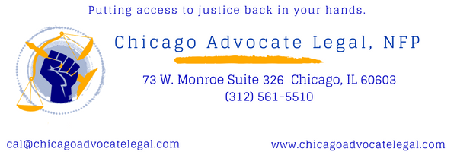

Chicago Advocate Legal, NFP Computer Science Internship
Introduction
CAL Is looking for an undergraduate or graduate student pursuing a bachelor’s or master’s degree in computer science, computer engineering, information technology or similar engineering field from an accredited program.
Scope of Responsibility/Expectation:
The computer science/software engineering intern will actively participate in the design and development of software that enables staff to organize and improve the intake process, improve organization and application of the nonprofit legal apprenticeship, and website and app for summer fundraisers.
Responsibilities include: Analysis of user experience and interactions, problem solving, design and implementation of simple and complex elegant software solutions, design validation and system integration.
The intern will develop a web-based application for CAL’s Nonprofit Legal Apprentice program, Paint the Town fundraiser and Fall-Fun Scavenger Hunt using python, PHP, SQL, Java, JavaScript, and C/C++/C#. The intern will use avaible hardware and software tools to assist in developing and debugging of the CAL Legal Fee Calculator and Client online intake form. The intern will work closely with CAL legal staff to implement software.
Specific Knowledge/Skills:
Must be pursuing a bachelor's or master's degree in computer science, computer engineering, information technology or similar engineering field from an accredited program.
Experience in any of the following areas will be helpful:
- HTML5, CSS, Javascript/AJAX, PHP, Python, SQL and other web development technologies
- Smartphone & Tablet software development using Java on the Android platform
- HTTP/HTTPS protocols and Apache, LightHTTPD or similar Web Servers.
- Object Oriented Analysis and Design
The ideal candidate should have:
- Strong troubleshooting skills
- Effective written and verbal communication skills
- An intense desire to innovate
- Ability to work in a fast pace environment

