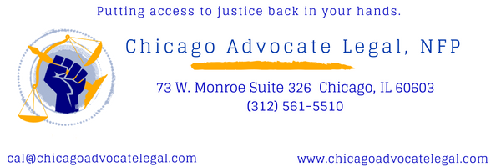

711 Part-time Summer Intern -

Chicago Advocate Legal, NFP(CAL) is a nonprofit law firm in the loop just two blocks from the Daley Center with four attorneys, a paralegal and a variety of interns. CAL is a fast-paced legal environment serving the needs of low and middle income individuals, families, and communities in Cook County. CAL focuses on family, housing, criminal and general civil litigation. Interns will get hands on experience.

Description

- Under the direction of the Staff Attorneys at Chicago Advocate Legal, NFP, the 711 Part-time Summer Intern will be:
  - Assisting with the analysis, review, and drafting of routine and complex motions, interviewing potential clients, representing clients in court, and communicating with clients about their cases.
  - Conducting legal research on relevant case law, laws/regulations, and other scholarly materials; and clearly and concisely summarizing his/her research in writing;
  - Using Microsoft Word, other software to prepare draft materials and communications; and
  - Performing administrative tasks as needed (e.g., organizing files and documents, making copies, and intake tracking on assigned cases).
- Position is Unpaid, but students can use this internship to apply for class credit.

Qualifications

This requisition will remain open until filled; however, first consideration will be given to those applicants who apply within the first 14 days.

Applicants must have/be:
- Eligible students are required to submit a resume and writing sample.
- 711 licensed or eligible for licensure.
Please send application materials to cal@chicagoadvocatelegal.com and address to Chlece Neal.

